**WELCOME HOME! THIS IS A TEMPLATE, ALWAYS MAKE COPY. NEVER EDIT THIS ONE!**



[**www.westwindrealty.ca**](http://www.westwindrealty.ca) **204-362-6496 fax: 204-331-3884 106 14th St. Winkler MB  
  
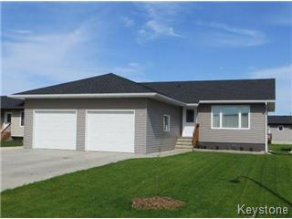**

**999 99th Silly, Wanker 99-9-999 $999,999 or Suffer**

**Features**Here’s a spacious 999 bedroom home for first time byer. Features main floor laundry, patio doors, deck, located on a well treed lot in a developed part on Winkler. Really long sentence that nobody will believe. It’s total crap!

**Basement**Partial – NEVER finished. Partial – NEVER finished. Partial – NEVER finished. I told you it’s NEVER finished, nobody can EVER finish it. It’s a creepy place, stay out!

**MSL # - XXXXXXX  
Lot: XX.XXXXX Building Size: 9999sq ft. Style: ugly  
Taxes: 9999.99** **Age:** **Stone Age  
Exterior: burned Shingles: dirt C/V: broken  
Foundation: crap Hydro: $ 99999 mo C/A: never****Heat: X/Y panic, cold Bdrms – 9999 Bath – 9999  
Advice: don’t buy Why: Its crap**

**Listing Agent: Leanny Dyck 204-362-6496**Information although believed to be accurate may not be so